# header

# Skreens AV Switch for Control4 Rev4.1

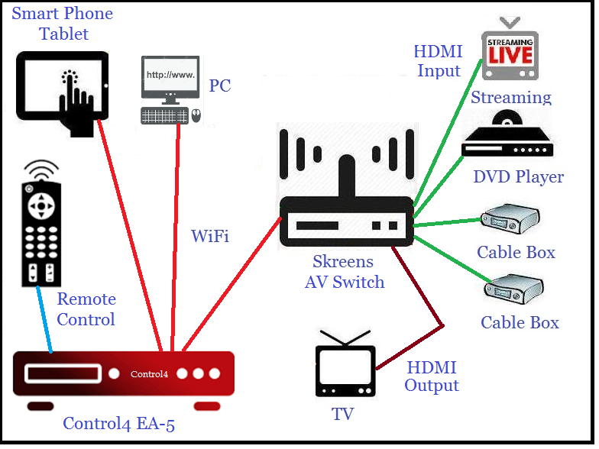

## Control4 EA-5 & Skreens AV Switch Physical Connection

The physical connections consist of a Control4 EA-5 Unit, referred to as “The Director”, a Skreens AV Switch Unit, used in conjunction with multiple HDMI Audio/Video input devices.

The Director can be controlled via remote control, a smart phone or a PC/Mac application.

**Skreens Entertainment Technology has developed a Control4 EA-5 Proxy Driver Unit which communicates with the Skreens AV Switch Unit.

The Skreens AV Switch Unit gets its commands from the proxy driver unit. The proxy driver unit performs either a Skreens specific operation, or passes the commands directly to one of the attached audio/video devices.

The output of the Skreens AV Switch Unit goes directly to the TV.

## Skreens Proxies

There are two Skreens Audio/Video Proxies implemented into the Control4 system. You can access both these proxies via either the C4 remote or the C4 Apps. Currently the Skreens AVx proxy is not used.

Skreens Remote Proxy: Press the “Watch” key and all device proxies will be listed, select the Skreens Remote Proxy.

### Skreens Remote Proxy

The Skreens Remote Proxy commands are used to control the appearance of the video display and the audio sources. These commands are used to navigate the screen layout positioning and window configurations. When in the Skreens remote proxy mode, the remote keystrokes are directed to the Skreens proxy driver until a specific layout configuration is selected. A detailed description of each command is described in another section listed below.

## Skreens On Screen Display Operation

The On Screen Display (OSD) control consists of 5 options: Layout, Home, Status, Swap, and Help. These 5 options are detailed below.

### One Screen Display Timeout

Whenever any of the On Screen Display modes are initiated, the display will remain active for a preset time before timing out and canceling. This time period is based on the remote being idle for the entire timeout period. Any remote navigation will reset the timeout back to the beginning of the timeout period.

### Layouts On-Screen-Display

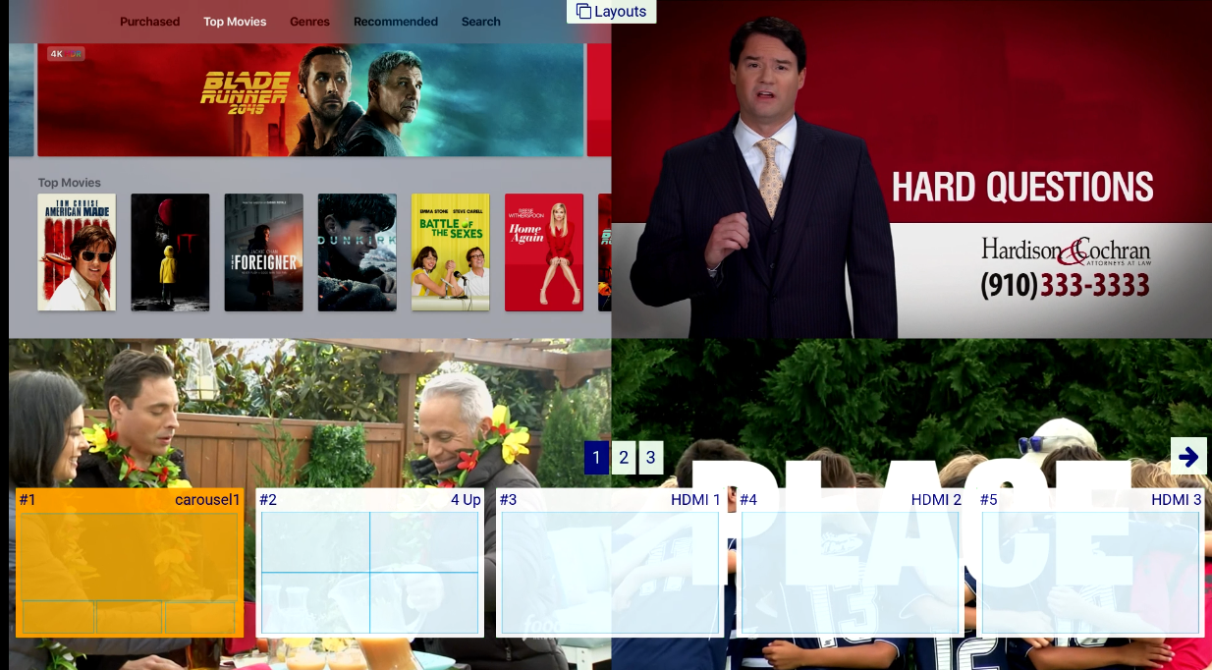

Layout control is initiated by pressing the GUIDE key on the C4 remote, or the EJECT key on your smart phone app or the PC/MAC App.

Once the layout control is initiated, a series of layout diagrams appear on the bottom of the display. Here you can navigate to a desired layout using the left and right arrow keys. Make your selection by pressing the SELECT key.

### Status On-Screen-Display

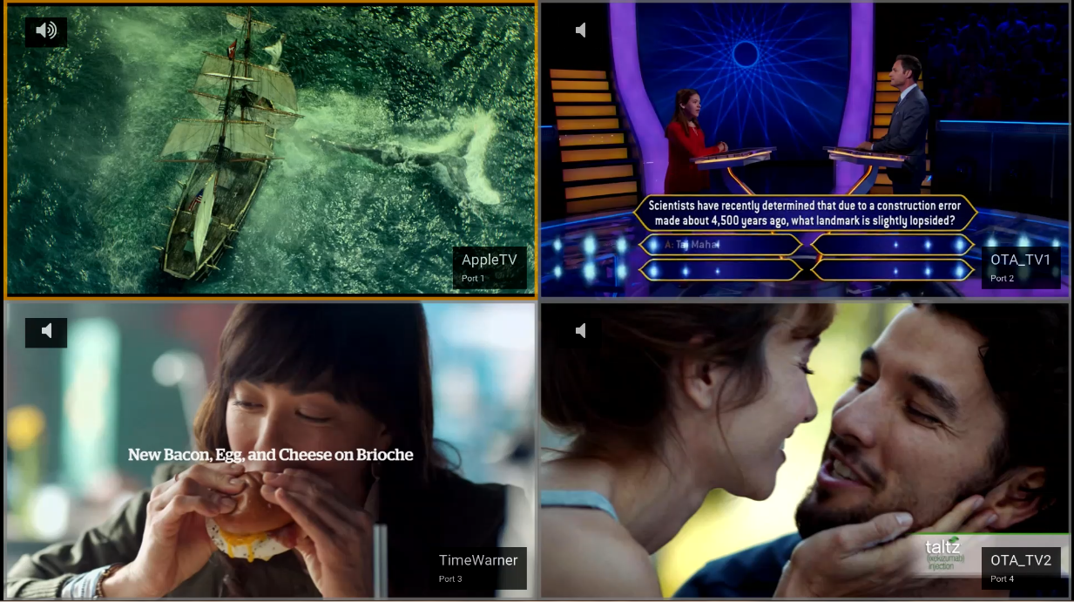

Status Control is initiated by pressing the SELECT key when no other OSD mode is selected. A yellow frame will appear to determine which window has the focus. The right and left arrow keys are used to navigate to other windows. At this point, you can either press the SELECT key to move the audio to the currently selected window, or you can press the PLAY key to bring the currently selected window to full screen. For either of these operations, the audio will follow the selected window. All remote control keys will now be sent directly to the device providing the A/V source.

### Swap On-Screen-Display

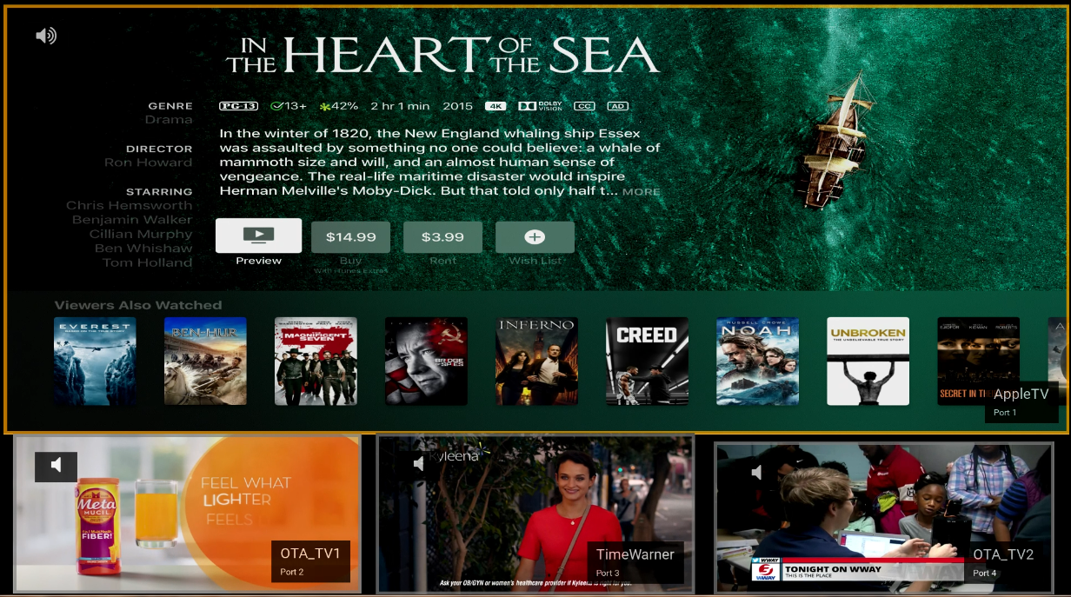

Swap Control Navigation uses the CH+ and CH- keys to swap windows from one position to another. The example layout below illustrates how to watch a program of interest in a large window, and when another interest starts playing, you can quickly swap windows to start watching the other program in the large window.

### Home On-Screen-Display

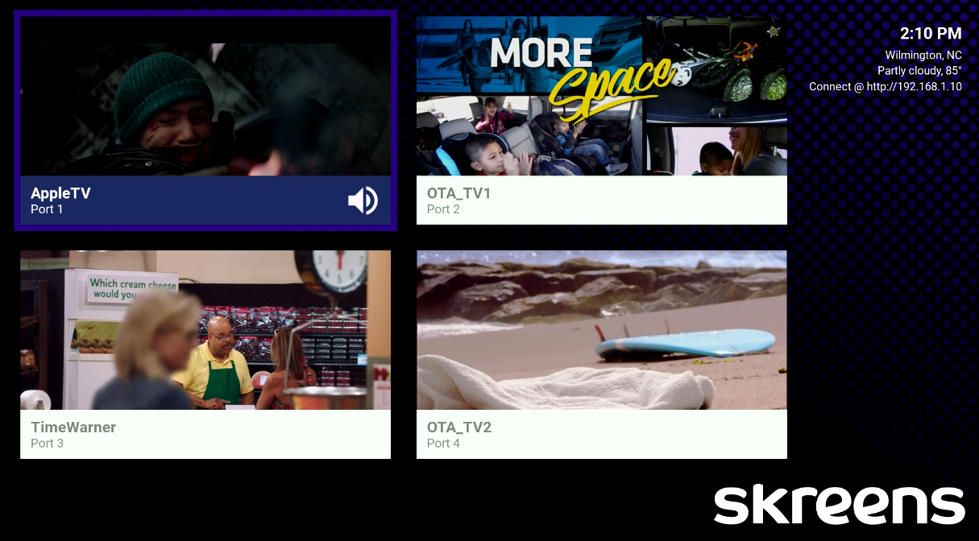

Home Control is initiated by pressing the key defined on the properties setup page. The default key is the BLUE custom control key. This displays the video content for all 4 inputs, plus information related to your location, Time and weather.

### Help On-Screen-Display

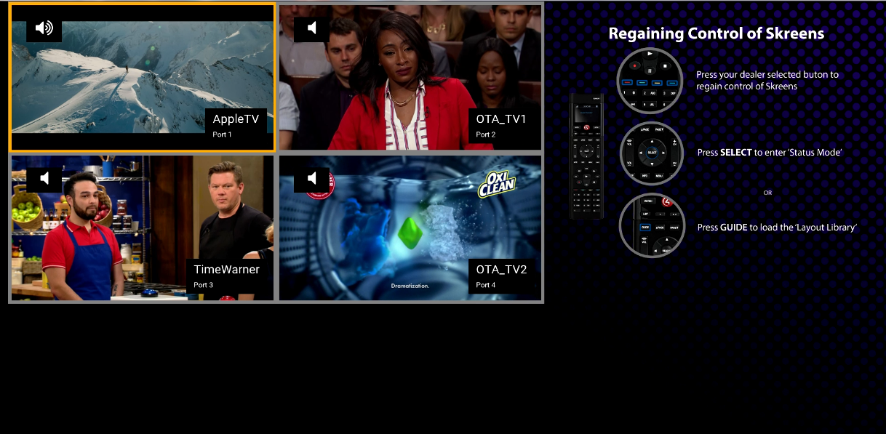

Help Control is initiated by pressing the Info key. This displays the video content for all 4 inputs, plus an illustration of the remote control layout.

Using the left and right arrow keys, you can cycle through all 4 layouts, and then press the SELECT key to bring the layout to full screen. The remote control key layout on the right will automatically cycle through multiple pages that illustrate many of the remote key definitions.

## Skreens Remote Control Key Definitions

Skreens remote control keys are used to navigate through a series of video screen layouts and to alter audio sources. Below is the list of keystrokes and a definition for each.

OSD = On Screen Display

### GUIDE

Enter LAYOUTS OSD mode: Displays a layout selector strip on the bottom of the display.

### EJECT

Same as GUIDE, this is exclusive to smart phone and PC apps.

### SELECT

Enter Status mode: While not in any OSD mode, this is used to initiate other sequences.

### INFO

Enter INFO OSD mode: Displays the video content for all 4 inputs, plus an illustration of the remote control layout.

### MENU

Enter MENU OSD mode: Will display a list of devices attached to the Control4 Director. (not yet available)

### RIGHT

While in OSD status mode: Navigates to the **right** by one.

### LEFT

While in OSD status mode: Navigates to the **left** by one.

### UP

While in OSD status mode - Swap UP sequence – for smart phone and pc apps. (lack of CH+ CH-).

### DOWN

While in OSD status mode - Swap DOWN sequence – for smart phone and PC apps. (lack of CH+ CH-).

### CH+

While in OSD status mode - Swap Window sequence FOWARD.

### CH-

While in OSD status mode - Swap Window sequence BACKWARD.

### CNCL

Cancels all OSD modes.

### PLAY

While in OSD status mode - the selected window goes to full screen.

### PREV

Used to jump back and forth to the previous video/audio configurations.

### PAGE UP

Cycle Audio selection FOWARD.

### PAGE DOWN

Cycle Audio selection BACKWARD.

### STAR

Used to initialize the default audio/video settings and rediscover all attached device state(s).

### POUND

# key - returns to the default layout.

## Remote Interception Control

The remote interception control is used to return the remote control keys back to the Skreens AV proxy. When the remote is being used to control one of the audio/video input devices, there needs to be a special remote key to allow the Skreens remote proxy to intercept keystrokes.

When configuring the Skreens AV switch in the C4 composer program, there is an option to select which special key to be used for the properties operation. Refer to section 1.6.4 Return Control To Screens.

The default is the red custom color key, located above the remote number keys. You can program this special key to be either the red, green, yellow, blue, or the key with the 3 dots.

## Skreens Proxy Driver Properties Options

The Skreens Proxy Properties page provides key options that can be used to control the operation of the driver.

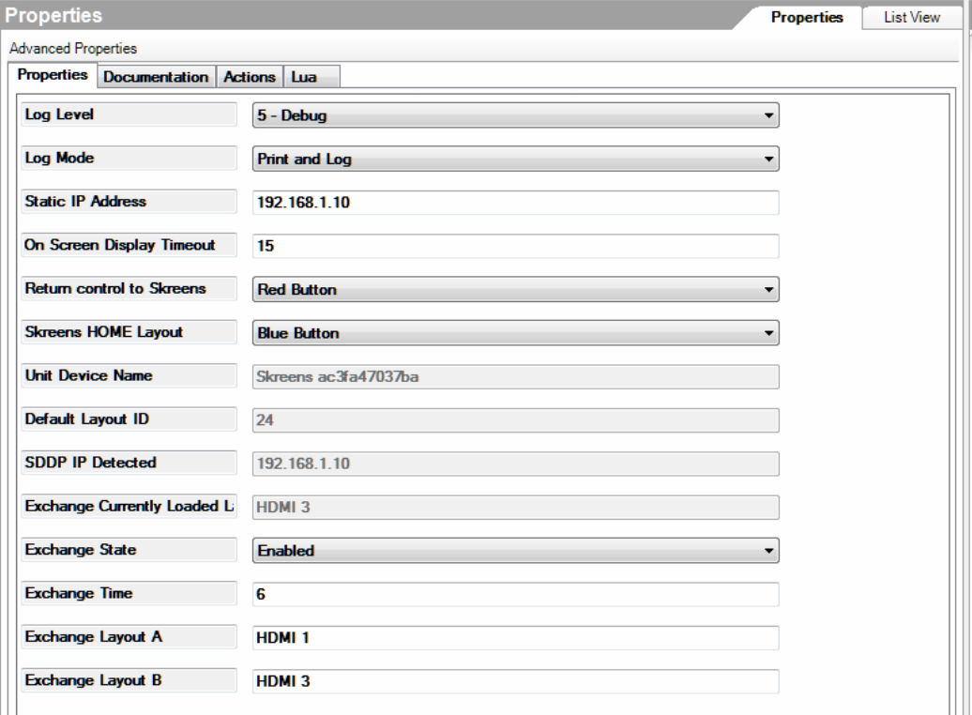

### Log Level and Mode

These options work together to provide logging and trace information to help debug and configure the driver. The output of these messages can be found in the LUA tab under LUA output.

### Static IP Address

This option is used to assign a static IP to the Skreens hardware that you want to control. As long as the SDDP functions are running, you typically will not need to set this up. The SDDP functions will do this automatically.

### On Screen Display Timeout

On Screen Display Timeout is used to control the amount of idle time before the OSD display image will terminate. This amount of time (in seconds) will be idle time. Any remote or app keystroke will reset the time to the start. A value of zero will disable the timeout all together. The maximum time value is 30 seconds.

### Return Control to Skreens

When you want to create a single key to return to the Skreens proxy, choose either:

- 3 dots on the C4 remote

- One of the 4 custom color keys available on the C4 remote

-One of the 4 custom color keys available on the C4 app

-Always On, which keeps all key control in the Skreens proxy.

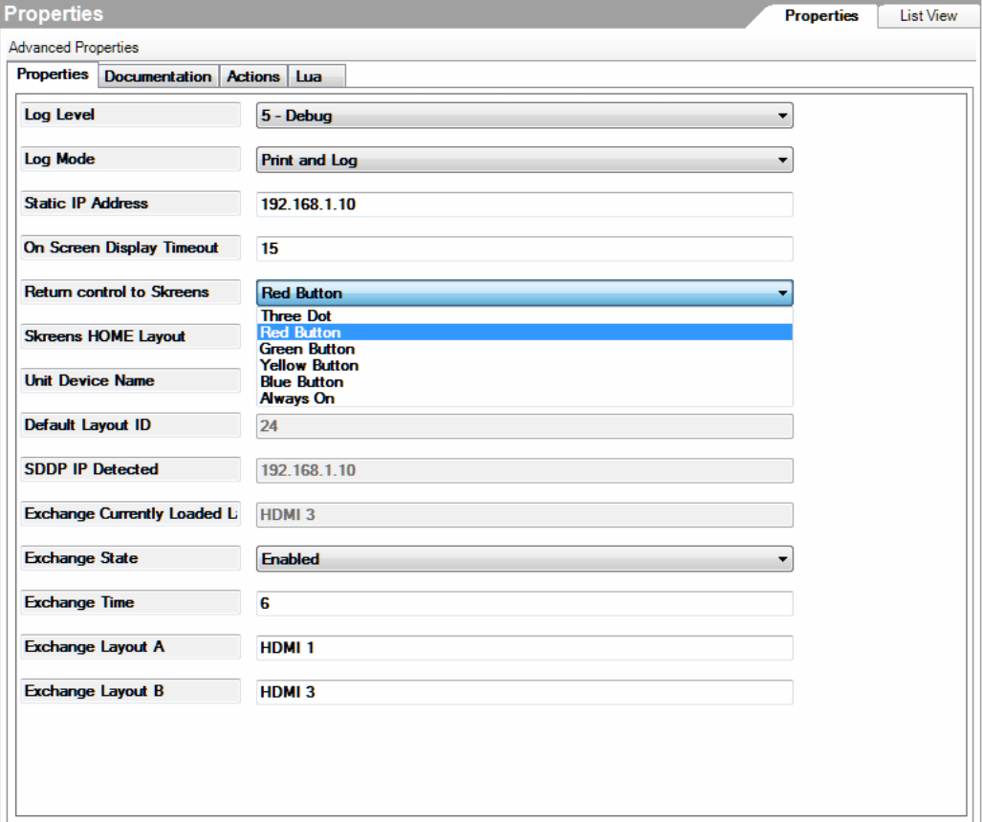

### Skreens HOME Layout

Designates a single remote key to execute the OSD home layout, see choices below:

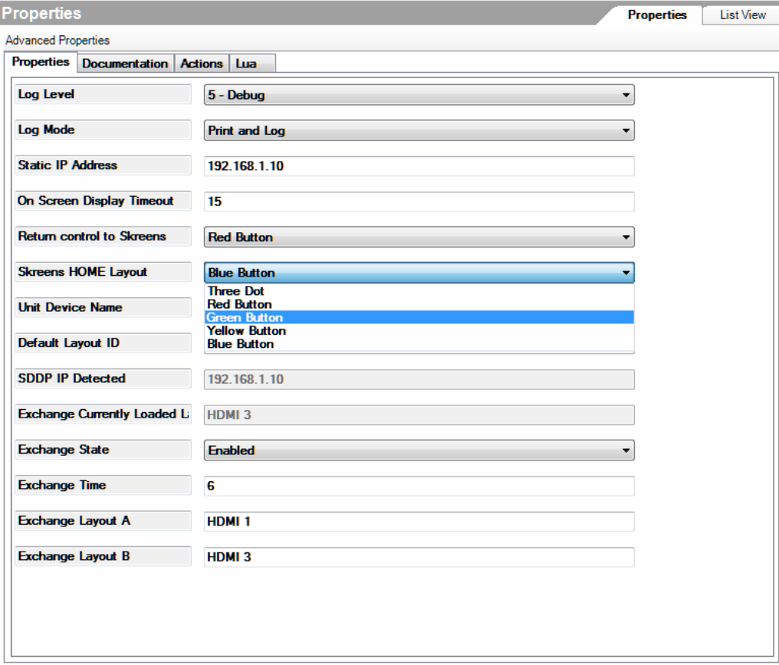

The options available are the 3 dots on the C4 remote, or one of the 4 custom color keys available on the C4 remote or the C4 app.

### Unit Device Name

This displays the name of the Skreens AV switch hardware.

### Default Layout ID

This displays the ID associated to the default layout that will be loaded when the Skreens proxy driver first starts up. Layout name and IDs are described in the section “Selecting a Default Layout”.

### SDDP ID Detected

This IP address is the address detected by the SDDP auto detect functionality. The Skreens unit broadcasts this IP periodically, and the Composer director grabs this address and makes it available to the proxy driver.

### Selecting a default layout

To obtain a list of available layout and associated IDs, select the “Actions” tab, and then press “Select Default Layout”. A window will pop up that has an entry for “Layouts”. By pressing the 3 dot button in the upper right corner, a second window will pop up with a “Layout Inventory “ list of available layouts. Select the layout that you want for the default layout and press OK.

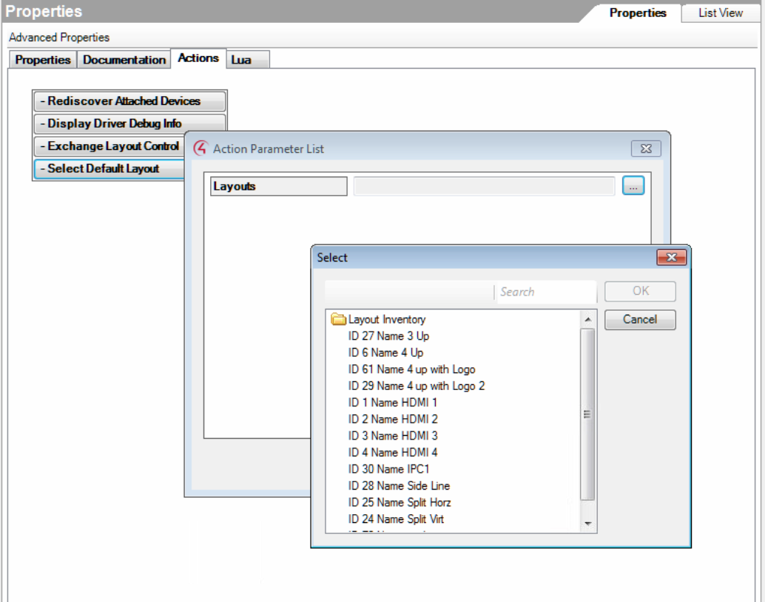

## Exchange layout toggling mechanism

The layout exchange mechanism is used when you want to swap back and forth between selected layout A and selected layout B. This mechanism has to be controlled from within the Composer application, and defaults to being disabled.

Once enabled, you can select the names of the 2 layouts that you would like to toggle between. Then select an amount of time (in seconds) that each of the layouts will be displayed before swapping to the alternate layout.

Next select the “Actions” tab, and then Press “Exchange Layout Control”, which toggles between START and STOP.

### Exchange Currently Loaded Layout

This field displays what is currently loaded, and will change when the layout exchange occurs.

Also references the actions tab where you will find an Exchange Layout Control button. This is used to start and stop the exchange swapping if enabled.

### Exchange State

The exchange state is used to enable/disable the exchange mechanism. The default is disabled.

### Exchange Time

The exchange time is the amount of time- in seconds- that each of the layouts will be displayed before swapping to the alternate layout.

### Exchange Layout A

Name of the layout used for position A.

To get a list of the available layouts, refer to section “Selecting a Default Layout” above . The names entered are not case sensitive.

### Exchange Layout B

Name of the layout used for position B.

Table of Contents

1 Skreens AV Switch for Control4 Rev4.1 1

1.1 Control4 EA-5 & Skreens AV Switch Physical Connection 2

1.2 Skreens Proxies 2

1.2.1 Skreens Remote Proxy 2

1.2.2 Skreens AV Proxy 3

1.3 Skreens On Screen Display Operation 3

1.3.1 One Screen Display Timeout 3

1.3.2 Layouts On-Screen-Display 4

1.3.3 Status On-Screen-Display 5

1.3.4 Swap On-Screen-Display 6

1.3.5 Home On-Screen-Display 7

1.3.6 Help On-Screen-Display 8

1.4 Skreens Remote Control Key Definitions 9

1.4.1 GUIDE 9

1.4.2 EJECT 9

1.4.3 SELECT 9

1.4.4 INFO 9

1.4.5 MENU 9

1.4.6 RIGHT 9

1.4.7 LEFT 9

1.4.8 UP 9

1.4.9 DOWN 9

1.4.10 CH+ 10

1.4.11 CH- 10

1.4.12 CNCL 10

1.4.13 PLAY 10

1.4.14 PREV 10

1.4.15 PAGE UP 10

1.4.16 PAGE DOWN 10

1.4.17 STAR 10

1.4.18 POUND 10

1.4.19 Remote Interception Control 10

1.5 Skreens Proxy Driver Properties Options 11

1.5.1 Log Level and Mode 11

1.5.2 Static IP Address 12

1.5.3 On Screen Display Timeout 12

1.5.4 Return Control to Skreens 12

1.5.5 Skreens HOME Layout 13

1.5.6 Unit Device Name 14

1.5.7 Default Layout ID 14

1.5.8 SDDP ID Detected 15

1.5.9 Selecting a default layout 15

1.6 Exchange layout toggling mechanism 16

1.6.1 Exchange Currently Loaded Layout 16

1.6.2 Exchange State 16

1.6.3 Exchange Time 16

1.6.4 Exchange Layout A 16

1.6.5 Exchange Layout B 16